Portobello
Primary School

AI Policy

Introduction and Purpose

Online safety forms part of the school’s wider duty of care. This policy supports the school in meeting its statutory safeguarding obligations and managing the safe use of emerging technologies.
At Portobello Primary School we recognise the increasing role of Artificial Intelligence (AI) in education and society. This policy outlines how AI can be used in schools and highlights how to approach using AI safely, ethically and effectively to support teaching, learning and school operations.
We are committed to high-quality, inclusive education and to preparing pupils for a digital future. AI is a tool to support—not replace—professional judgement and human interaction.
This policy aligns with:
- Department for Education (DfE) guidance on generative AI
- UK GDPR and the Data Protection Act 2018

Scope
This policy applies to all members of the school community, including staff, pupils, governors and volunteers. It covers the use of AI in teaching and learning, assessment, and administrative tasks.
The policy applies both to school-approved AI tools and to any broader use of AI technologies in school-related contexts.
Definitions and Understanding AI
Artificial Intelligence (AI) refers to systems that perform tasks requiring human intelligence, such as language processing, pattern recognition and problem-solving.
Relevant types in school contexts include:
- Generative AI – creates content such as text, images or quizzes
- Adaptive platforms – personalise learning based on pupil responses
- Accessibility tools – e.g. text-to-speech or translation
It is important to recognise that while AI can be a powerful support, it does not have understanding or awareness in the way humans do. It can make mistakes, reflect bias, and produce inaccurate or misleading information. For this reason, all use of AI within the school must include appropriate human oversight.
Further information can be found here: Generative artificial intelligence (AI) in education - GOV.UK
Ethical Use
All users must be aware of the limitations and risks of AI:
- Bias - data and information generated by AI will reflect any inherent biases in the data set accessed to produce it. This could include content which may be discriminatory based on factors such as race, gender, or socioeconomic background.
- Accuracy – information may be inaccurate when generated so any content should be fact-checked. Tools may provide highly plausible and coherent results but may still contain errors (Hallucination).
- Human oversight – a lack of staff intervention may result in AI outputs going unchecked. Staff will ensure that outputs align with ethical standards and educational values, and staff should be aware that Generative AI lacks flexibility, human understanding and compassion.
- Currency – some AI models only collate data prior to a certain date so content generated may not reflect the most recent information.
- Environmental issues –AI requires energy to run. Therefore, it should only be used when relevant, appropriate and proportionate, where it is the most suitable and sustainable option.
- Inferring Emotion - The European Union's Artificial Intelligence Act (AI Act) imposes strict regulations on the use of emotion recognition systems (ERS) within workplaces and educational institutions. These systems, defined as AI tools designed to identify or infer emotions or intentions of individuals based on their biometric data, are generally prohibited in these settings. Although the Act does not apply in the UK, this type of AI should not be used in Portobello Primary School.

Use by Staff
Staff may use AI to support:
- planning and resource creation
- administration and workload management
- generating ideas and summaries
- create assessment
Staff must:
- review and adapt all AI-generated content
- ensure outputs are accurate and appropriate
- use AI critically and professionally
AI should not replace direct teaching or meaningful interaction with pupils. Staff should use AI critically, ensuring that all outputs are checked for accuracy and suitability before use in the classroom.
The Flow Charts (Appendices 2 and 3) to assess appropriate use of AI in class and with pupils and The CARE Framework (Appendix 4) may be used with staff to support effective and responsible use.
Use by Pupils
The school recognises that most generative AI tools have age restrictions and are not designed for direct use by primary-aged pupils. However, pupils may encounter AI within school through approved educational technologies, such as AI-assisted search results, accessibility tools, coding and programming platforms, or other digital learning resources. It is also acknowledged that pupils may encounter and use such technologies outside of school. The school will help pupils to understand when AI is being used and how to engage with it safely, critically and responsibly.
The school will:
- teach pupils about AI in an age-appropriate way
- develop critical thinking about AI-generated content
- ensure any classroom use is:
  - approved by senior leaders
  - supervised at all times
Pupils will be taught to:
- question AI outputs
- recognise inaccuracies
- verify information using reliable sources
- know how to respond if something inappropriate is seen (seek adult support)
Safeguarding and Online Safety
As part of child protection and safeguarding policies and processes, the school will ensure that pupils continue to be protected from harmful online content, including content that may be generated by AI technologies. Any authorised AI tools used within school will be reviewed to ensure they are appropriate to pupils’ age, stage of development and educational needs.
Staff will be made aware of the potential risks associated with AI, including the generation of harmful, misleading or inappropriate material, such as deepfakes and impersonation content. This awareness supports staff in identifying and responding to safeguarding concerns effectively.
This approach is in line with statutory safeguarding guidance, including Keeping Children Safe in Education (KCSIE), which requires schools to ensure appropriate filtering, monitoring and staff awareness of online risks, and to adapt safeguarding practices in response to emerging technologies.
Any concerns relating to AI-generated content or misuse will be reported in line with the school’s safeguarding procedures to the Designated Safeguarding Lead.
Approved Tools and Platforms
The school’s default AI platform is Microsoft Copilot (Microsoft 365).
This platform:
- operates within the school’s secure environment
- protects data under GDPR-aligned controls
- does not use school data to train AI models
Use of other AI tools (e.g. ChatGPT, Google Gemini) is permitted only if:
- no personal or sensitive data is entered
- no images of pupils or staff are uploaded
- no pupil work is uploaded
- no school intellectual property is shared
- all outputs are reviewed by a teacher
Data Protection and Privacy
All use of AI must comply with data protection law.
- No personal or sensitive data must be entered into public AI tools
- Staff must understand whether tools are open (data shared) or closed (secure)
A Data Protection Impact Assessment (DPIA) will be completed:
- before introducing any new AI tool
- where AI processes personal data or is used by pupils
Any breaches will be managed in line with the school’s Data Protection Policy.
Intellectual Property and Copyright
When using AI tools in primary schools, it is essential that pupils and staff understand and respect intellectual property and copyright laws. AI-generated content may rely on existing sources, so users should acknowledge original creators, avoid plagiarism, and check permissions before using or sharing materials.
It is also important to protect and value children’s own work; pupils should be encouraged to recognise their creations as their intellectual property and to use AI as a tool to support—not replace—their thinking and originality. Schools should promote responsible use by ensuring that any text, images, or media created or adapted with AI are appropriately credited and compliant with copyright regulations, helping pupils develop strong digital citizenship from an early age.

Equality and Inclusion
The school recognises that AI systems may reflect bias present in their training data. Staff should be aware of this and take steps to ensure that materials and outputs are inclusive and appropriate.
AI could also be used, where possible, to support accessibility and inclusion. For pupils with SEND, decisions about the use of AI-supported interventions should be guided by recommendations from relevant SEND professionals and specialist services, with AI used where it supports and aligns with agreed educational strategies and individual pupil needs.
Staff Training and Professional Development
Building staff confidence in using AI responsibly is essential to ensuring its effective and safe implementation.
Staff will receive training to:
- understand AI risks and benefits
- use AI safely and effectively
Ongoing support will be provided as technology evolves.
Governance and Responsibilities
The Headteacher and Senior Leadership Team are responsible for implementation.
- Designated Safeguarding Lead (DSL) oversees safeguarding concerns
- Data Protection Officer (DPO) ensures GDPR compliance, including completion of DPIAs
Other staff, including subject leaders, will support implementation within their areas. Governors will monitor the policy and its impact.
Monitoring and Review
The use of AI will be monitored by senior leaders and the governing body to ensure:
- compliance with this policy
- positive impact on teaching and learning
The policy will be reviewed twice a year to reflect changes in guidance and technology.
Responding to Misuse
Misuse of AI will be addressed in line with:
- behaviour policy
- safeguarding procedures
Concerns must be reported to senior leaders. Appropriate action will be taken based on severity.
Links to Other Policies
- Safeguarding
- Data protection
- Acceptable use of technology
- Behaviour policy

Appendix 1 - Glossary of AI Terms
Artificial Intelligence (AI)
Technology that enables computers to perform tasks that typically require human intelligence, such as problem-solving or generating text.
Generative AI
AI systems that can create new content, such as text, images, or audio (e.g. chatbots or image generators).
Machine Learning (ML)
A type of AI where systems learn patterns from data to improve performance over time.
Algorithm
A set of rules or instructions a computer follows to complete a task.
Bias (AI Bias)
When an AI system produces unfair or skewed results due to the data it was trained on.
Data Privacy
Protecting personal information from misuse or unauthorised access.
Personal Data
Information that identifies a person, such as name, address, or school records.
Large Language Model (LLM)
An AI system trained on large amounts of text to understand and generate human-like language.
Prompt
The input or question given to an AI system to generate a response.
Misinformation
Incorrect or misleading information that may be presented as fact.
Human Oversight
Ensuring a person reviews and takes responsibility for AI-generated content.

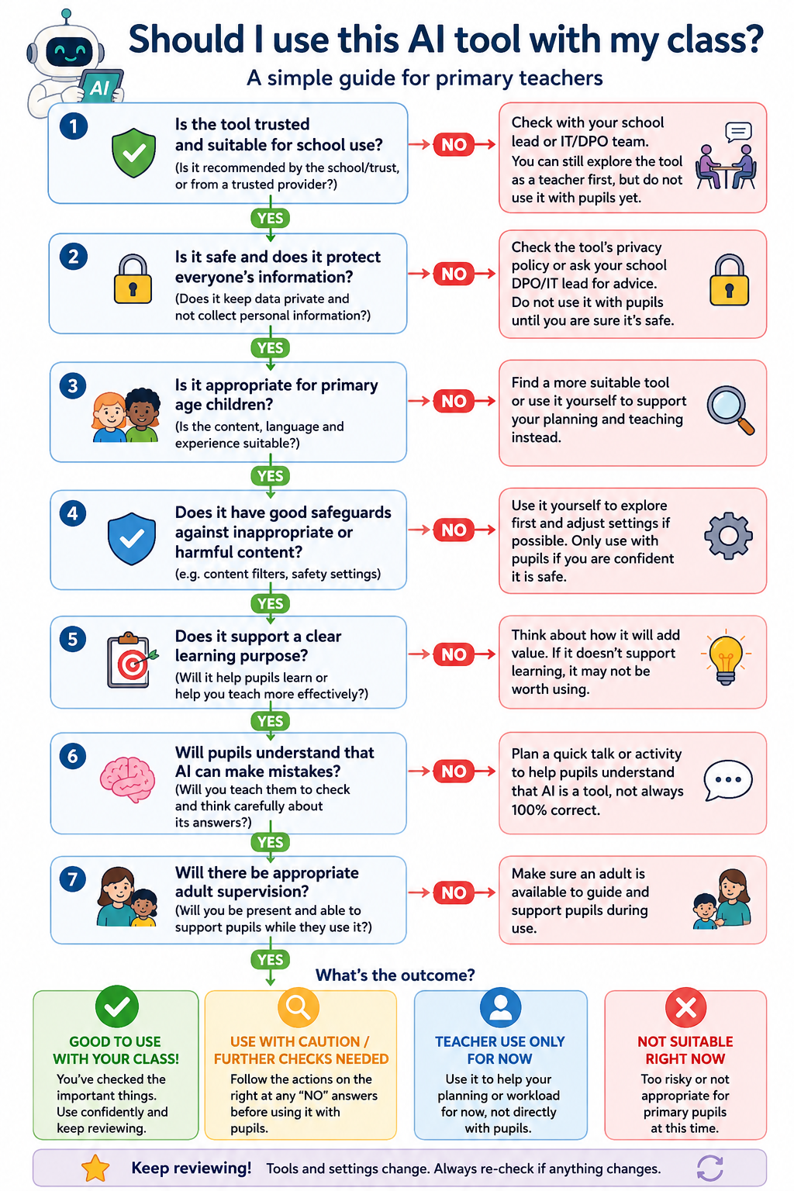
Appendix 2 – Flow Chart for Assessment of Suitability of AI for class use

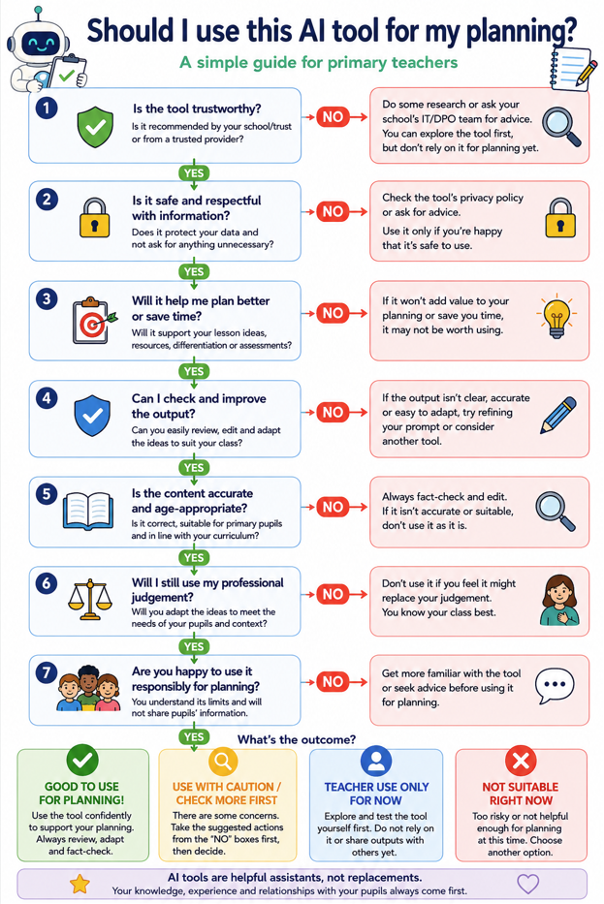
Appendix 3 - Flow Chart for Assessment of Suitability of AI for planning

Appendix 4 – The CARE Framework

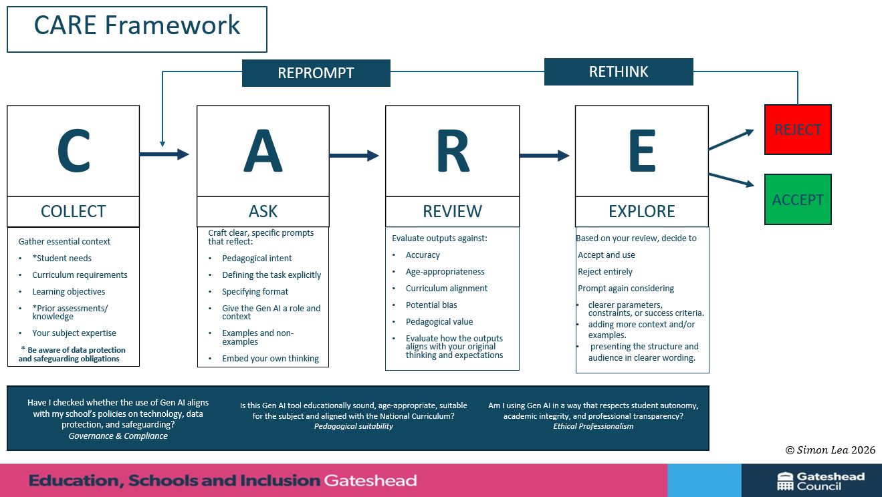

Appendix 5 – Useful resources to support use of AI in primary schools
Generative AI in Education
The DfE's official guidance on the safe, effective and responsible use of generative AI in schools and colleges. This should be the primary reference document for school leaders.
https://www.gov.uk/government/publications/generative-artificial-intelligence-in-education
Using AI in Education Settings – Support Materials
Free training materials for school staff covering AI awareness, safe use, prompting, risks and practical applications.
https://www.gov.uk/government/collections/using-ai-in-education-settings-support-materials
Using AI in Education – Support for School and College Leaders
Leadership guidance to help schools implement AI safely and strategically.
https://www.gov.uk/government/publications/using-ai-in-education-support-for-school-and-college-leaders
Data Protection and AI in Schools
DfE guidance on protecting personal data when using generative AI tools in education settings.
https://www.gov.uk/guidance/data-protection-in-schools/generative-artificial-intelligence-ai-and-data-protection-in-schools
Data Protection and Privacy
Information Commissioner's Office (ICO) – AI and Data Protection
Guidance on using AI lawfully, fairly and transparently, including DPIAs and data protection responsibilities.
https://ico.org.uk/for-organisations/uk-gdpr-guidance-and-resources/artificial-intelligence/

Safeguarding and Online Safety
UK Safer Internet Centre
Advice, guidance and teaching resources covering online safety, emerging technologies and AI-related risks.
https://saferinternet.org.uk
CEOP Education
Resources, training and guidance to support online safety education and safeguarding.
https://www.ceopeducation.co.uk
Thinkuknow
Age-appropriate online safety resources for children, parents and schools from the National Crime Agency.
https://www.thinkuknow.co.uk
SWGfL – Artificial Intelligence and Online Safety
Practical advice for educators on discussing AI with pupils and understanding emerging online risks.
https://swgfl.org.uk/topics/artificial-intelligence/
Childnet – Artificial Intelligence Resources
Resources for schools and families covering AI literacy, online safety and responsible use.
https://www.childnet.com/resources/
Approved School Platforms
Microsoft Copilot for Education
Information about Microsoft's AI tools for education, including responsible use and data protection features.
https://www.microsoft.com/education/copilot

