Our Safeguarding Children Team



Designated Safeguarding
Deputy

Name: Miss Clarke
Title: SENCO

Designated Safeguarding
Deputy

Name: Mr Chipchase
Title: Senior Leader


Designated Safeguarding
Lead

Name: Mrs Humphrey
Title: Head Teacher


Designated Safeguarding
Deputy

Name: Miss West
Title: Deputy Head Teacher

If you are concerned about a child please talk to us

I have a safeguarding concern relating to a child, parent or member of staff

1
Our Safeguarding Children Process

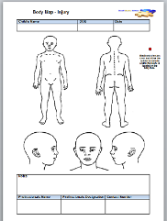
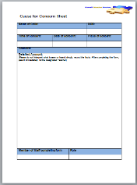
Write down your concern on a cause for concern sheet
2

Where appropriate the Designated Safeguarding Lead will give feedback. In some incidences the case details may be confidential

Designated Safeguarding Lead

Name: Mrs Humphrey
Title: Head Teacher

Add photo here

Designated Safeguarding Deputy

Name: Miss West
Title: Deputy Head Teacher

Designated Safeguarding Deputy

Name: Mr Chipchase
Title: Senior Leader

Designated Safeguarding Deputy

Name: Miss Clarke
Title: SENCO

Inform a member of the Safeguarding Team
3
Other useful contacts:

NSPCC
Tel: 0808 800 5000

Children’s Social Care
Tel: 0191 4332653

Police
Tel: 101 (non emergency)
Tel: 999 (emergency)

Feedback to the referrer
6
Advice will be given on the next steps
4
A plan will be put in place
5
This may or may not involve a referral to Social Care

This may or may not involve actions to be taken by the referrer

