Portobello Primary School
Calculation Policy


Ratified by Governors on: November 2022
Signed: __________________

Purpose
This calculation policy has been produced to ensure consistency and progression in teaching throughout the school in line with the New National Curriculum 2014. It aims to give an overview of the key written calculation strategies that will be taught in each year group. The policy demonstrates the progression in each of the four operations that children will typically follow. Each stage builds upon previous experience, knowledge and skills.
Children will develop calculation skills through a combination of practical, oral and mental activities. The children’s formal and informal calculations will be strengthened through the development of a conceptual understanding and fluency by experiencing concrete, visual and abstract representations of a concept during a lesson. Working in this manner will help our students to connect abstract symbols with familiar contexts, thus providing the opportunity to make sense of, and develop fluency in the use of, abstract symbols.

Although the focus of this policy is on pencil and paper procedures, it is important to recognise that in every written method there is an element of mental processing. Written calculation strategies will therefore be taught alongside mental calculation strategies and should be seen as complementary to and not as separate from them. Likewise, informal written recording will take place regularly and is an important part of learning and understanding. More formal written methods follow only when the child is able to use a wide range of mental calculation strategies.

Although using and applying is now not an explicit strand within the New National Curriculum 2014 all calculations and methods should be taught with the key aims of the curriculum. These are fluency, reasoning and problem solving and children will be provided with opportunities to demonstrate this.

Addition +
Key skills for Year 1 Addition –

- Read, write and interpret mathematical statements involving addition (+) and equals (=) signs
- Add one-digit and two-digit numbers to 20, including zero
- Represent and use number bonds and related subtraction facts within 20
- Solve one-step problems that involve addition using concrete objects and pictorial representations
- Missing number problems such as 9 =  + 2

Strategies
Addition by combining two sets of concrete objects | Addition using Numicon
Counting on using number strings | Hold a number in your head and count on using your fingers or objects
Missing numbers (empty box problem) using Numicon | Counting on using number line

Addition +
Key skills for Year 2 Addition –

- Solve problems with addition:
  - using concrete objects and pictorial representations, including those involving numbers, quantities and measures
- Recall and use addition and subtraction facts to 20 fluently, and derive and use related facts up to 100
- Add numbers using concrete objects, pictorial representations, and mentally, including:
  - a two-digit number and ones
  - a two-digit number and tens
  - two two-digit numbers
  - adding three one-digit numbers
- Show that addition of two numbers can be done in any order (commutative) and subtraction of one number from another cannot
- Recognise and use the inverse relationship between addition and subtraction and use this to check calculations and solve missing number problems.
Strategies
Adding by partitioning with numicon | Adding with partitioning with dienes  T:  O:
Adding multiples of ten using hundred square | Adding multiples of ten on blank number line
Expanded column addition TO + TO (supported with dienes)  O:  T: |  | Column addition T + TO  T O  4 5  + 3 3  7 8

Addition +
Key skills for Year 3 Addition –
- Add numbers mentally, including:
  - a three-digit number and ones
  - a three-digit number and tens
  - a three-digit number and hundreds
- Add numbers with up to three digits, using formal written methods of columnar addition
- Estimate the answer to a calculation and use inverse operations to check answers
- Solve problems, including missing number problems, using number facts, place value, and more complex addition
- Add fractions with the same denominator within one whole (e.g. 5/7 + 1/7 = 6/7)

Strategies
Column method with dienes | Formal column method HTO + HTO
HTO + TO using a bar model  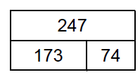  173 + 74 = 247 | Add fractions with the same denominator bar model  4/10 + 3/10 = 7/10  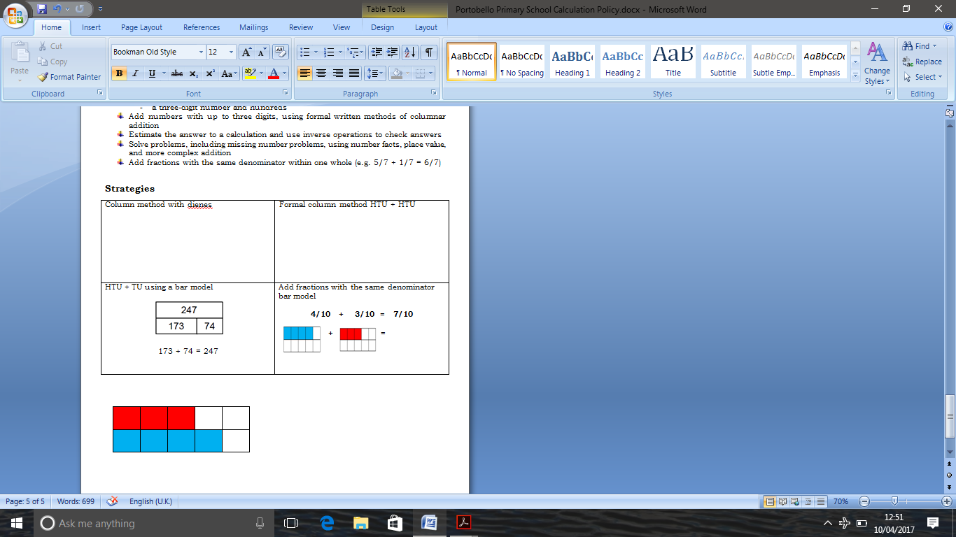  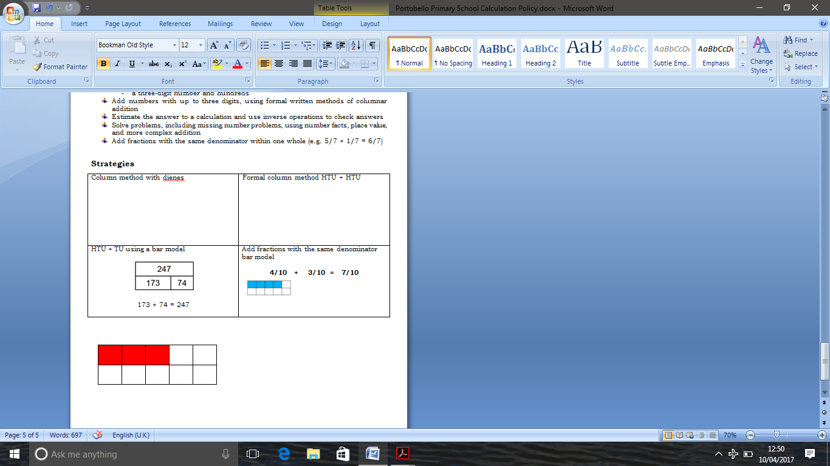  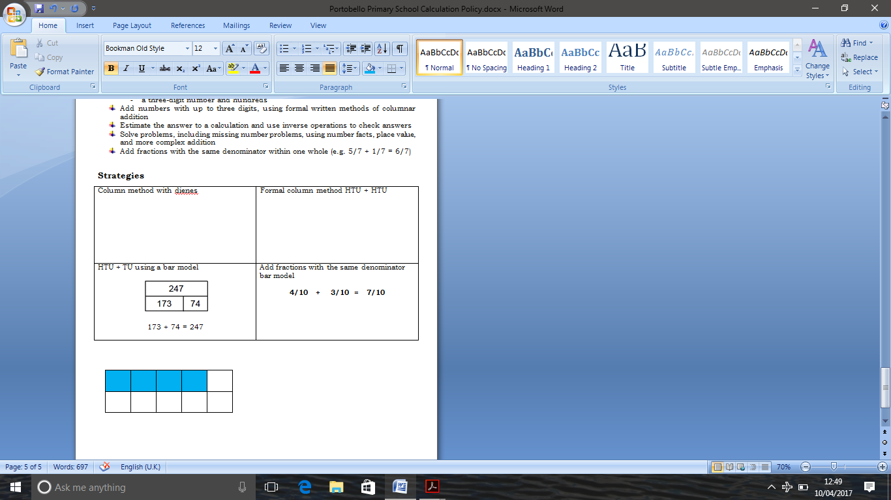  + =

Addition +
Key skills for Year 4 Addition –
- Add numbers with up to 4 digits using the formal written methods of columnar addition
- Estimate and use inverse operations to check answers to a calculation
- Solve addition two-step problems in contexts, deciding which operations and methods to use and why
- Add fractions with the same denominator (This may exceed the whole)
- Solve simple measure and money problems involving fractions and decimals to two decimal places.

Strategies
Column Method ThHTO + ThHTO
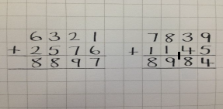

Column method with coins used for £ and pence | Formal column method with decimals in the context of money  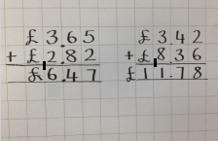

Addition +
Key skills for Year 5 Addition –
- Add whole numbers with more than 4 digits, including using formal written methods (columnar addition)
- Add numbers mentally with increasingly large numbers
- Use rounding to check answers to calculations and determine, in the context of a problem, levels of accuracy
- Solve addition multi-step problems in contexts, deciding which operations and methods to use and why
- Add fractions with the same denominator and multiples of the same number
- Solve problems involving numbers up to three decimal places

Strategies
Formal column method with hundreds of thousands
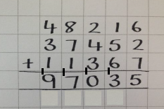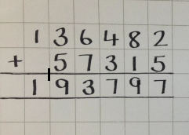

Formal column method with decimals in the context of measures  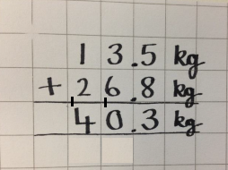 | Formal column method with decimals with 3dp (Using 0 as a place holder)

Addition +
Key skills for Year 6 Addition –
- Solve addition multi-step problems in contexts, deciding which operations and methods to use and why
- Solve problems involving addition
- Use estimation to check answers to calculations and determine, in the context of a problem, levels of accuracy.
- Add fractions with different denominators and mixed numbers, using the concept of equivalent fractions

Strategies
Formal column method with decimals with 3dp  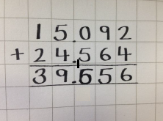 | 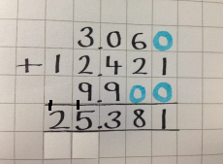Adding more than one decimals number
Addition up to million
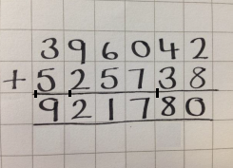

Subtraction -
Key skills for Year 1 Subtraction –
- Read, write and interpret mathematical statements involving subtraction (-) and equals (=) signs
- Subtract one-digit and two-digit numbers to 20, including zero
- Represent and use number bonds and related subtraction facts within 20
- Solve one-step problems that involve subtraction, using concrete objects and pictorial representations
- Missing number problems such as 7 =  - 9

Strategies

Counting back using number strings | Counting back using number line
Removing from a sets of concrete objects | Subtraction by covering Numicon
Hold a number in your head and count back using your fingers or objects | Missing numbers using Numicon –difference

Subtraction -
Key skills for Year 2 Subtraction –
- Solve problems with subtraction using concrete objects and pictorial representations, including those involving numbers, quantities and measures
- Recall and use addition and subtraction facts to 20 fluently, and derive and use related facts up to 100
- subtract numbers using concrete objects, pictorial representations, and mentally, including:
  - a two-digit number and ones
  - a two-digit number and tens
  - two two-digit numbers
- Show that addition of two numbers can be done in any order (commutative) and subtraction of one number from another cannot
- Recognise and use the inverse relationship between addition and subtraction and use this to check calculations and solve missing number problems.

Strategies
Subtraction with partitioning using dienes | Subtracting multiples of ten on a 100 sq
Subtracting multiples of ten on blank number line | Subtracting TO on blank number line
Expanded column subtraction TO - TO (supported with dienes)

Subtraction -

Key skills for Year 3 Subtraction –
- Subtract numbers mentally, including
  - a three-digit number and ones
  - a three-digit number and tens
  - a three-digit number and hundreds
- Subtract numbers with up to three digits, using formal written methods of columnar subtraction
- Estimate the answer to a calculation and use inverse operations to check answers
- Solve problems, including missing number problems, using number facts, place value, and more complex subtraction
- Subtract fractions with the same denominator within one whole (e.g. 6/7 - 5/7 = 1/7)

Strategies

Column method with dienes | Column method with dienes (including exchanging)
Formal column method HTO - HTO

Subtraction -
Key skills for Year 4 Subtraction –
- Subtract numbers with up to 4 digits using the formal written methods of columnar subtraction where appropriate
- Estimate and use inverse operations to check answers to a calculation
- Solve subtraction two-step problems in contexts, deciding which operations and methods to use and why
- Subtract fractions with the same denominator

Strategies

Column Method ThHTO – ThHTO | Column method with coins using to represent £ and p
Formal column method with decimals in the context of money

Subtraction -

Key skills for Year 5 Subtraction –
- Subtract whole numbers with more than 4 digits, including using formal written methods (columnar subtraction)
- Subtract numbers mentally with increasingly large numbers
- Use rounding to check answers to calculations and determine, in the context of a problem, levels of accuracy
- Solve subtraction multi-step problems in contexts, deciding which operations and methods to use and why
- Subtract fractions with the same denominator and multiples of the same number
- Solve problems involving numbers up to three decimal places

Strategies

Formal column method with hundreds of thousands | Formal column method with decimals in the context of money
Formal column method with decimals with 3dp (Using 0 as a place holder)

Subtraction -
Key skills for Year 6 Subtraction –
- Solve subtraction multi-step problems in contexts, deciding which operations and methods to use and why
- Solve problems involving subtraction,
- Use estimation to check answers to calculations and determine, in the context of a problem, levels of accuracy.
- Subtract fractions with different denominators and mixed numbers, using the concept of equivalent fractions

Strategies
Formal column method of decimals with 3dp | Formal column method with decimals of different decimal places
Subtraction including millions

Multiplication X
Key skills for Year 1 Multiplication –
- Solve one-step problems involving multiplication by calculating the answer using concrete objects, pictorial representations and arrays

Strategies

Combining groups of Numicon | Combining groups of objects
Pictorial representations | Drawing arrays

Multiplication X
Key skills for Year 2 Multiplication –
- Calculate mathematical statements for multiplication within the multiplication tables and write them using the multiplication (×) and equals (=) signs
- Show that addition of two numbers can be done in any order (commutative) and subtraction of one number from another cannot
- Solve problems involving multiplication using materials, arrays, repeated addition, mental methods, and multiplication, including problems in contexts

Strategies

Drawing arrays | Repeated addition with numicon
Repeated addition on a blank number line

Multiplication X
Key skills for Year 3 Multiplication –
- Write and calculate mathematical statements for multiplication using the multiplication tables that they know, including for two-digit numbers times one-digit numbers, using mental and progressing to formal written methods (appears also in Mental Methods)

Strategies

Grid method with an array | Grid method using Cuisenaire rods
Grid method with numbers | Expanded short multiplication TU x U
Short multiplication
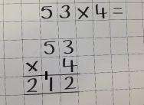

Multiplication X
Key skills for Year 4 Multiplication –
- Multiply two-digit and three-digit numbers by a one-digit number using formal written layout
- Solve problems involving multiplying and adding, including using the distributive law to multiply two digit numbers by one digit, integer scaling problems and harder correspondence

Strategies

Grid multiplication HTO x O using dienes to support

Expanded short multiplication HTO x O | Short multiplication  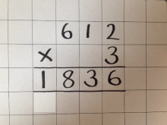

Multiplication X
Key skills for Year 5 Multiplication –
- Multiply numbers up to 4 digits by a one- or two-digit number using a formal written method, including long multiplication for two-digit numbers
- Multiply whole numbers and those involving decimals by 10, 100 and 1000
- Solve problems involving multiplication and division including using their knowledge of factors and multiples, squares and cubes
- Solve problems involving addition, subtraction, multiplication and division and a combination of these, including understanding the meaning of the equals sign
- Solve problems involving multiplication including scaling by simple fractions and problems involving simple rates
- Multiply proper fractions and mixed numbers by whole numbers, supported by materials and diagrams

Strategies
Expanded long multiplication ThHTO x O  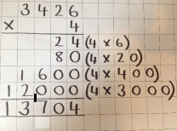 | Short multiplication ThHTO x O  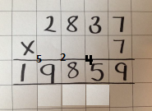
Compact long multiplication HTO x O & HTO x T  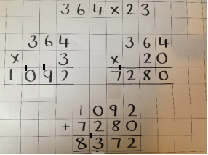 | Short multiplication ThHTO x TO

Multiplication X
Key skills for Year 6 Multiplication –
- Multiply multi-digit numbers up to 4 digits by a two-digit whole number using the formal written method
- Use estimation to check answers to calculations and determine, in the context of a problem, levels of accuracy
- Solve problems involving addition, subtraction, multiplication and division
- Multiply one-digit numbers with up to two decimal places by whole numbers
- Multiply simple pairs of proper fractions, writing the answer in its simplest form (e.g. 1/4 × 1/2 = 1/8)
- Solve problems which require answers to be rounded to specified degrees of accuracy

Strategies

Short multiplication for ThHTO x TO | Short multiplication O.th x HTO

Division ÷
Key skills for Year 1 Division –
- Solve one-step problems involving division, by calculating the answer using concrete objects, pictorial representations and arrays.

Strategies

Groups of Numicon | Sharing using objects
Pictorial representations | Arrays

Division ÷
Key skills for Year 2 Division –
- Calculate mathematical statements for division within the multiplication tables division (÷) and equals (=) signs
- Solve problems involving division, using materials, arrays, repeated addition, mental methods, and multiplication and division facts, including problems in contexts

Strategies
Drawing arrays | Repeated subtraction with numicon
Repeated subtraction on a blank number line

Division ÷
Key skills for Year 3 Division –
- Write and calculate mathematical statements for multiplication and division using the multiplication tables that they know, including for two-digit numbers divided by one-digit numbers, using mental and progressing to formal written methods
- Solve problems, including missing number problems, involving division, including positive integer scaling problems and correspondence problems in which n objects are connected to m objects

Strategies

Repeated subtraction on a blank number line including groups of 10 | Repeated subtraction on a blank number line including groups multiples of 10
Division in the form of chunking

Division ÷

Key skills for Year 4 Division –
- Short division TO ÷ O using compact method
- Find the effect of dividing a one- or two-digit number by 10 and 100, identifying the value of the digits in the answer as ones, tenths and hundredths

Strategies

Division by subtracting chunks with multiples of 10 | Formal compact division using partitioning and dienes
Formal compact division using partitioning | Formal compact division without remainders TO ÷ O

Division ÷

Key skills for Year 5 Division –
- Divide numbers up to 4 digits by a one-digit number using the formal written method of short division and interpret remainders appropriately for the context
- Divide whole numbers and those involving decimals by 10, 100 and 1000
- Solve problems involving division including using their knowledge of factors and multiples, squares and cubes
- Solve problems involving addition, subtraction, multiplication and division and a combination of these, including understanding the meaning of the equals sign
- Solve problems involving division, including scaling by simple fractions and problems involving simple rates

Strategies
Formal compact division using partitioning | Formal compact division without remainders ThHTO ÷ O
Formal compact division ThHTO ÷ O with remainders

Division ÷

Key skills for Year 6 Division –
- Divide numbers up to 4-digits by a two-digit whole number using the formal written method of short division
- Where appropriate for the context divide numbers up to 4 digits by a two-digit whole number using the formal written method of long division, and interpret remainders as whole number remainders, fractions, or by rounding, as appropriate for the context
- Use estimation to check answers to calculations and determine, in the context of a problem, levels of accuracy
- Solve problems involving addition, subtraction, multiplication and division
- Solve problems which require answers to be rounded to specified degrees of accuracy
- Use written division methods in cases where the answer has up to two decimal places

Strategies
Formal compact division with remainder | Formal compact division and express remainder as a fraction
Formal compact division and express remainder as a decimal | Formal compact division TU.th ÷ U
Division with chunking for dividing by 2 digits

