

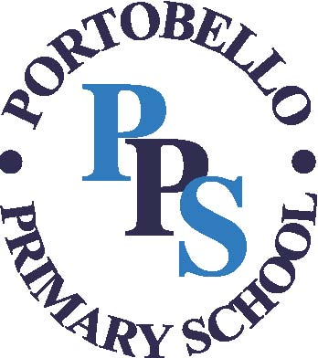







Portobello Primary School
Tantallon
Birtley
Chester-le-street
DH3 2LY
T 0191 410 4571
F 0191 410 9146
E: portobelloprimaryschool@gateshead.gov.uk
W: www.portobelloprimary.eschools.co.uk
Twitter: @portobellopri
Mrs J Humphrey
Head Teacher

Dear Parent/Carer
Re: Breakfast Club
Breakfast club is available to pupils in Early Years, KS1 and KS2.
Places are limited to 40 pupils per day and bookings/payments can be made via School Gateway, ideally a week in advance, this is to ensure we have the correct staffing for our staff to pupil ratio, for health and safety reasons.
How to book Breakfast Club – go to School Gateway, sign in and under school clubs you will see a Breakfast Club booking option, you can book onto individual days or full weeks whatever is your requirement, you can do this weekly or termly or for the full academic year if needed.
Should you wish to book your child for every morning – you will need to click on each individual day option and add to your basket. You will then have for example Monday, Tuesday, Wednesday, Thursday and Friday in your basket to check out. Payments must be made at the time of booking. If you only wanted three mornings, you would add whichever days you needed and then check out and make payment.
Payment is £3.00 per child per day and breakfast club is open from 7.45am, latest drop off to school is 8.25am should your child require a breakfast.
Children will have a choice of toast, cereal, yogurt and there is juice, water, or milk to drink. Breakfast club will advertise “special breakfasts” throughout the year too such as, Pancake Day.
Any questions at all please contact school via telephone or email address below, Mrs Lister our School Business Manager is available regarding any queries.
Your Sincerely
Mrs J Humphrey
Head Teacher E: portobelloprimaryschool@gateshead.gov.uk T: 0191 4104571

