Portobello Primary School


Oracy Policy
2025

Ratified by Governors: Autumn Term 2025

Review date: September 2027

Amendment:

Rationale

Many children start early school life without the oracy skills relevant for their age. Therefore, from the very outset of joining our school, we strive to develop spoken language skills through the taught curriculum, playtimes and lunchtimes, extra-curricular activities and the whole ethos of the school. Oracy is essential for boosting academic confidence across curriculum areas. Having an oracy-rich classroom where children are given the space to explore their ideas with their friends can make them feel more confident in their own ideas as well as their academic performance. Oracy is about learning to talk and learning through talk. We believe spoken language to be fundamental to the achievement our children. At Portobello Primary, we want all children to be equipped with the skills that they need to be able to use their voice for success now and to thrive in their future life. We incorporate the teaching of oracy skills within our curriculum. To ensure we are teaching oracy skills across the curriculum and providing our children with a range of oracy opportunities, and a variety of audiences, we follow the Gateshead progression documents, ensuring that every voice is heard, valued and developed.

Aims of our Oracy Policy

Relationships are key and central to everything we do. As a whole school staff, we therefore foster good communication amongst ourselves, with our children, their parents and carers, and with the wider community. We place a high priority on supporting the development of good speaking and listening skills amongst our children. Therefore, we strive to build a culture of oracy within our school to support and develop our children’s confidence, spoken language and written outcomes across and beyond the curriculum. We aim to have children who can communicate effectively and confidently in front of any type of audience.

Our oracy curriculum will enable us to:
- Embed and teach oracy skills in all curriculum areas, in lessons, and throughout the entire school day
- Encourage children to talk in full sentences with a clear and confident voice, with clarity and fluency
- Explicitly teach children to explore ideas through talk; challenge each other’s opinions and develop their own reasoned arguments
Our oracy curriculum will enable children to:
- Recognise the value of listening
- Be confident in the value of their own opinions and to be able to express them to others
- Adapt their use of language for a range of different purposes and audiences
- Concentrate, interpret and respond appropriately to a wide range of listening experiences
- Be open-minded, to value the contribution of others and to take account of their views

Children with SEN and Inclusion

At Portobello Primary School, we ensure that all our children are included within all aspects of the curriculum. Children with an Education Health Care Plan or with SEN School Support are encouraged to take an active part in spoken language activities appropriate for their needs. Targets are usually set by the class teacher, following the advice of our SENCO. Some of our children have input from outside agencies, such as speech therapists, and we welcome the expertise they bring to the school. Our Teaching Assistants are trained in programmes such as ELKAN, ELSA and Early Talk Boost which provide both staff and children with valuable tools, knowledge and skills.

Implementation

Oracy Cambridge and Voice 21 have worked together to publish the Oracy Skills Framework, which specifies the skills young people need in a range of talk situations. This has been used and adapted in the development of the Gateshead progression grids.

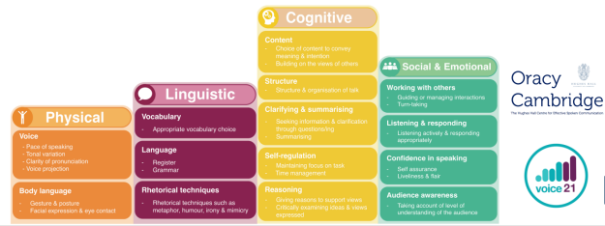

Each teaching staff will have access to the whole school overview. It is important for them to have a clear understanding of the skills and knowledge that should be in place from previous years and what they should be consolidating and practising as well as knowledge of the next steps.

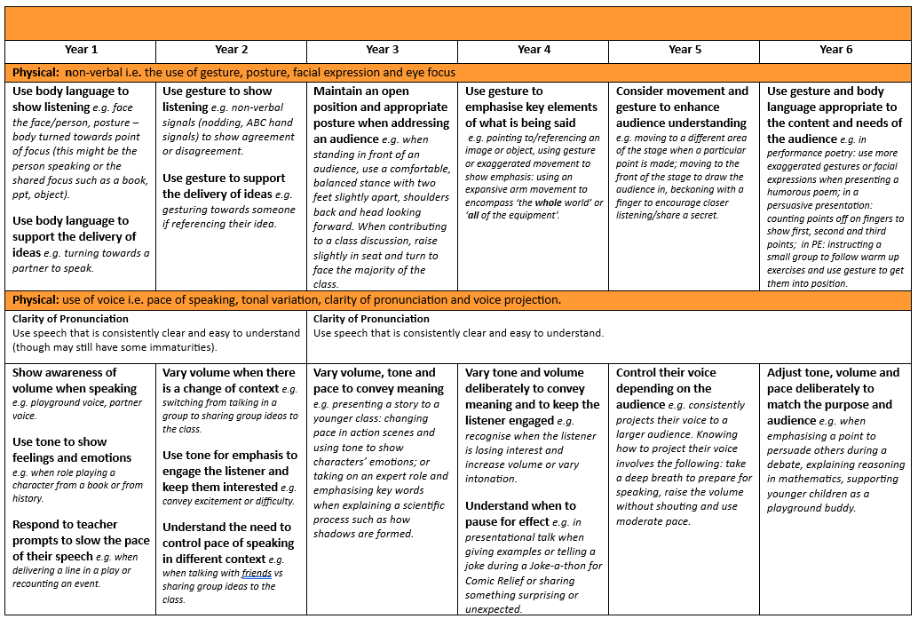

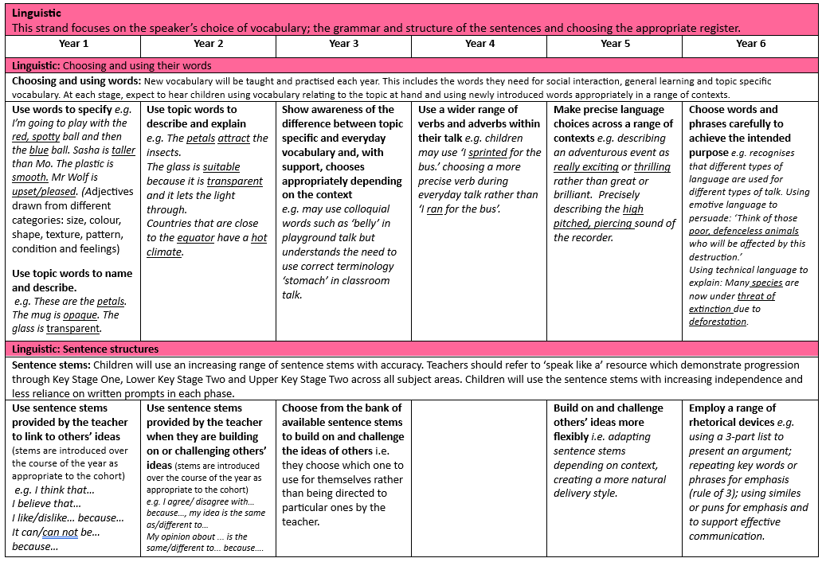

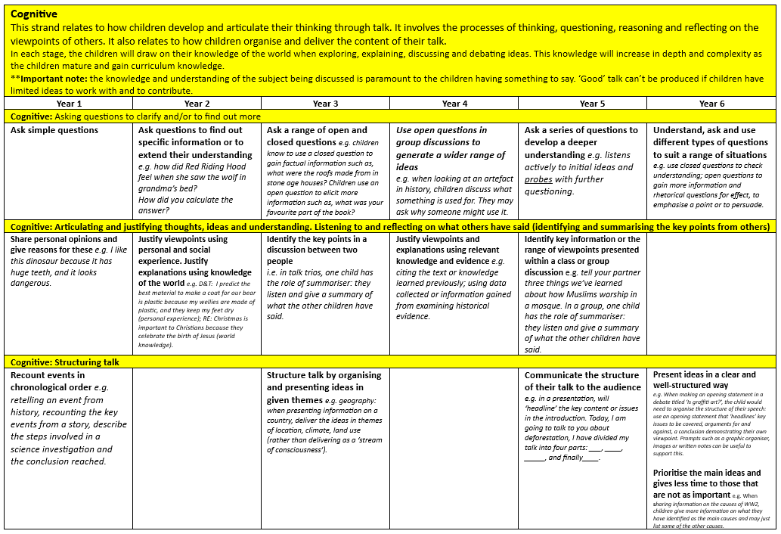

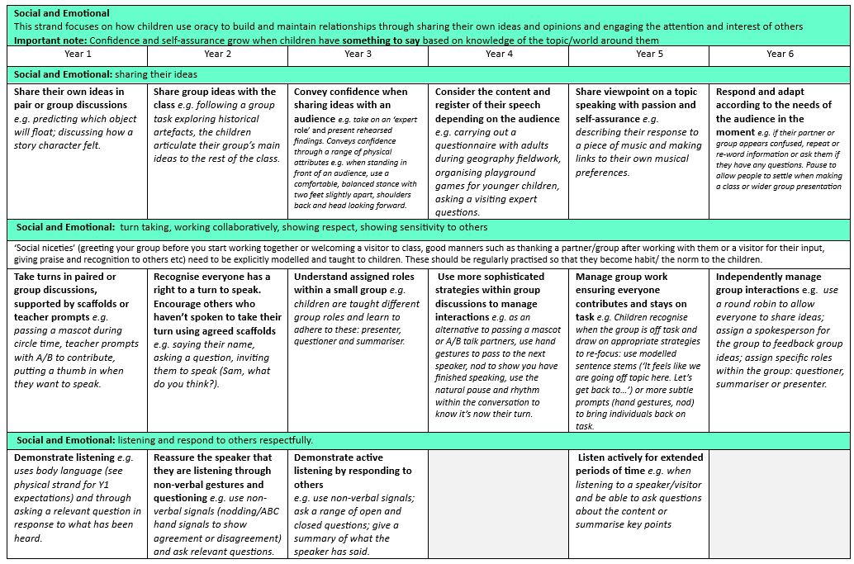

The Oracy Curriculum focuses on learning to talk and learning through talk. When learning to talk the curriculum teaches and develops the skills needed for clear communication. This includes how to talk in pairs, trios and groups; how to listen actively, build, challenge and reach consensus; how to choose words, gesture and tone carefully and purposefully to match purpose and how to structure and organise talk. Learning through talk develops and teaches listening and communication, and how these can be used as an approach to help children to explore understanding of new ideas, opinions and knowledge and to practise using new vocabulary and sentence structures.

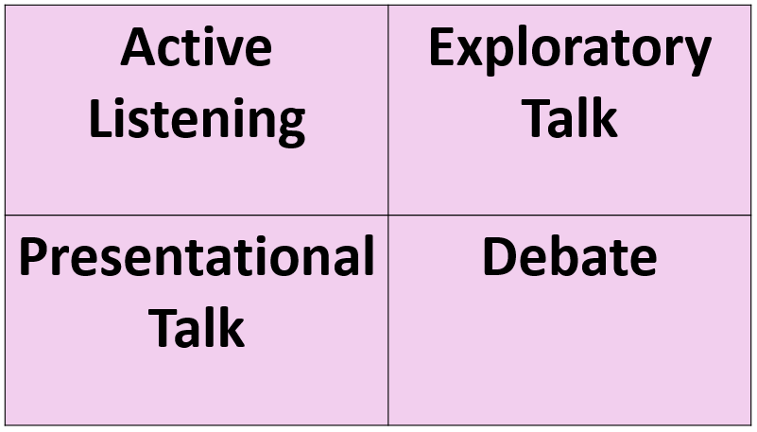

Roles and responsibilities

Teaching Staff will:

Teaching staff will be aware of and follow the guidance contained within this policy. They should seek advice from the subject leader if they are unsure of the content of the policy or curriculum. Teaching staff should implement the oracy curriculum within their daily practice

Subject Leaders will:

Subject leaders will remain responsible for the planning and delivery of the Oracy Curriculum. They will support staff through planned CPD and ad-hoc requests for assistance with knowledge or planning. Subject Leaders will monitor the teaching, learning and impact through a variety of methods: learning walks, learning outcome moderations, pupil voice and subject audits They will meet with the Senior Leadership Team to update them with current developments. It is their responsibility to ensure the policy is kept up to date.

Senior Leadership Team

The Senior Leadership Team will support the subject leader to be an advocate for the subject. They will ensure the subject leaders have sufficient CPD opportunities to develop staff knowledge.

Monitoring and Review

It is the responsibility of those working in school to follow the principles stated in this policy. The Head Teacher, Deputy Head Teacher and English Leader will carry out monitoring of the Oracy Curriculum as part of the whole school monitoring schedule. The English committee of The Governing Body will also be part of this process. This policy will be reviewed in September 2027.

Date Ratified by Governors:

Date of Review: September 2027

