**Our Safeguarding Children Team**



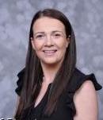

Designated Safeguarding

Deputy

Name: Miss Clarke

Title: SENCO

Designated Safeguarding

Deputy

Name: Mr Chipchase

Title: Senior Leader



Designated Safeguarding

Lead

Name: Mrs Humphrey

Title: Head Teacher



Designated Safeguarding

Deputy

Name: Miss West

Title: Deputy Head Teacher

**If you are concerned about a child please talk to us**

**I have a safeguarding concern relating to a child, parent or member of staff**

**Our Safeguarding Children Process**

**Write down your concern on a cause for concern sheet**

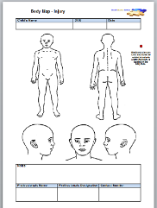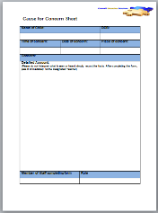



Where appropriate the Designated Safeguarding Lead will give feedback. In some incidences the case details may be confidential

Designated Safeguarding Lead

Name: Mrs Humphrey

Title: Head Teacher

Add photo here

Designated Safeguarding Deputy

Name: Miss West

Title: Deputy Head Teacher



Designated Safeguarding Deputy

Name: Mr Chipchase

Title: Senior Leader



Designated Safeguarding Deputy

Name: Miss Clarke

Title: SENCO



**Inform a member of the Safeguarding Team**

Other useful contacts:

**NSPCC**

**Tel: 0808 800 5000**

**Children’s Social Care**

**Tel: 0191 4332653**

**Police**

**Tel: 101 (non emergency)**

**Tel: 999 (emergency)**

**Feedback to the referrer**

**Advice will be given on the next steps**

**A plan will be put in place**

This may or may not involve a referral to Social Care

This may or may not involve actions to be taken by the referrer