Portobello Primary School


E-Safety Policy (September 2024)

Ratified by Governors: November 2024

Review date: November 2025

POLICY FOR ONLINE SAFETY

Mission Statement

Creating Confidence, Empowering Excellence, Igniting Independence

Introduction

This policy is a statement of the principles, aims, strategies and content of our e-safety provision. It is intended to act as a reference point and to inform teachers, parents, governors, LA officers and inspectors.

This policy was reviewed in September 2024 through a process of consultation with teachers, non-teaching staff, pupils, parents and Governors.

Rationale

The potential that technology has to impact on the lives of all people increases year on year. This is probably even truer for children, who are generally much more open to developing technologies than adults. In many areas, technology is transforming both the way schools teach and children learn. At home, technology is changing the way children live and the activities in which they choose to partake. These trends are set to continue. While developing technology brings many opportunities, it also brings risks and potential dangers.

The school identifies that the breadth of issues classified within online safety is considerable, but can be categorised into four areas of risk:
- Content: being exposed to illegal, inappropriate or harmful content. For example pornography, fake news, racism, misogyny, self-harm, suicide, anti-Semitism, radicalisation and extremism.
- Contact: being subjected to harmful online interaction with other users. For example, peer on peer pressure, commercial advertising and adults posing as children or young adults with the intention to groom or exploit children for sexual, criminal, financial or other purposes.
- Conduct: personal online behaviour that increases the likelihood of, or causes, harm. For example, making, sending and receiving explicit images (e.g. consensual and non-consensual sharing of nudes and semi-nudes and/or pornography), sharing other explicit images and online bullying.
- Commerce: risks such as online gambling, inappropriate advertising, phishing and or financial scams.

Aim

Children have the right to enjoy childhood online, to access safe online spaces,
and to benefit from all the opportunities that a connected world can bring to them, appropriate to their age and stage.
As they grow older, it is crucial that they learn to balance the benefits offered by technology with a critical awareness of their own and other’s online behaviour and develop effective strategies for staying safe and making a positive contribution online. E-safety is an extremely important part of our Computing Curriculum. Each term children receive direct teaching regarding the eight statements of the Education for a Connected World Framework. This includes:
- Self-image and identity
- Online relationships
- Online reputation
- Online bullying
- Managing online information
- Health, well-being and lifestyle
- Privacy and security
- Copyright and ownership

What is an e-safety policy?
This E-Safety Policy replaces the previous policy to reflect the need to raise awareness of the safety issues associated with information systems and electronic communications as a whole. E-safety encompasses, not only Internet technologies, but also electronic communications such as smartphones, tablets and other wireless devices.
Why have an e-safety policy?
It highlights the need to educate children and staff about the benefits, risks and responsibilities of using information technology. It provides safeguards and raises awareness to enable users to control their online experiences.
The Internet is an unmanaged, open communications channel. Anyone can send messages, discuss ideas and publish material with limited restriction. These features make it an invaluable resource used by millions of people every day. However, much of the material on the Internet is published for an adult audience and some is unsuitable for pupils. In addition, there is information on weapons, crime and racism – access to which would be more restricted elsewhere. Pupils must also learn that publishing information could compromise their security and that of others.
Why is use of the Internet important in supporting learning?
The Internet is an essential element in 21st century life for education, business and social interaction. The school has a duty to provide pupils with quality Internet access as part of their learning experience. Internet use is a part of the statutory curriculum and a necessary tool for staff and pupils.

How does the Internet benefit education?
Benefits of using the Internet include:
➢ Access to world-wide resources
➢ Educational and cultural exchanges between pupils world-wide
➢ Cultural, vocational, social and leisure use in all aspects of everyday life.
➢ Access to experts in many fields for staff and pupils
➢ Staff professional development through access to national developments, educational materials and good curriculum practice
➢ l developments, educational materials and effective curriculum practice
➢ Communication with support services, professional associations and colleagues
➢ Improved access to technical support including remote management of networks and automatic system updates
➢ Exchange of curriculum and administration data with the Local Authority and DfE
➢ Access to learning wherever and whenever convenient

How will Internet use enhance learning?
➢ School Internet access is designed expressly for pupil use and includes filtering appropriate to the age of the pupils
➢ Pupils will be taught what Internet use is acceptable and what is not and given clear objectives for Internet use
➢ Pupils will be educated in the effective use of the Internet in research, including exploring the validity of different sources
➢ Pupils will be shown how to publish and present information to a wider audience
➢ Internet access will be planned to enrich and extend learning activities as an integrated aspect of
the curriculum
➢ Staff will guide pupils in on-line activities that will support the learning outcomes planned for the pupils’ age and maturity
➢ Pupils will use the internet discerningly to answer key questions and follow lines of enquiry
➢ Pupils will select suitable websites and will be encouraged to take responsibility for their own internet access

How will pupils learn to evaluate Internet content?
➢ The school will ensure that the use of Internet derived materials by staff and pupils complies with copyright law
➢ Pupils will be taught the importance of cross-checking information before accepting its accuracy and to question the credibility of the information
➢ Pupils will be taught how websites are ranked when using search engines and how to avoid the bias and manipulation that is possible in the way results are presented
➢ Pupils will be taught how to report unpleasant Internet content.
➢ Staff will be made aware of how to report unpleasant Internet content; informing the Computing leader or a member of SLT directly
➢ Pupils will be informed that checks are made on files held on the system as part of the school’s work with the Internet Service Provider to ensure that pupils are protected
➢ Pupils will be taught to expect a wider range of content, both in level and in audience, than is found in the school library or on television.

How will Internet Access be managed?
➢ School ICT security and filtering systems provided and managed by Omnicom and Securus will be regularly reviewed and upgraded.
➢ Virus protection will be updated regularly.
➢ Personal data sent over the Internet will be encrypted or otherwise secured.

How will Removable Media and Hand-Held Devices be managed?
Removable media refers to anything that can be used for taking electronic information out of school. This includes USB sticks; memory cards etc. Also, many consumer electronic gadgets such as smartphones and tablets (iPads) can be used for removable data storage.

E-mail
The government encourages the use of e-mail as an essential means of communication for both staff and pupils. Directed e-mail use can bring significant educational benefits and interesting projects. However, un-regulated e-mail can provide a means of access to a pupil that bypasses the traditional school boundaries. In the school context, therefore, e-mail is not considered private and is monitored by staff, whilst trying to achieve a balance between monitoring that is necessary to maintain the safety of pupils and the preservation of human rights, both of which are covered by recent legislation.

Social Networking and E-Communication
Conferencing applications offering the instantaneous exchange of content between users have great potential for education and provide a basis for pupils’ understanding of global citizenship as they encounter different societies and cultures.
➢ Pupils will not be allowed access to public or unregulated social media.
➢ They will be closely supervised during well-planned activities and the importance of using technology safely and sensibly clearly emphasised.
➢ Pupils will be advised never to give out personal details of any kind which may identify them, their friends or their location.
➢ Pupils will be advised to use nicknames and avatars when using social networking sites.
➢ Pupils will use only moderated and carefully selected E-Communication sites
➢ Pupils and parents will be advised on how to safely utilise social networking spaces outside school.
➢ Mobile phones will not be used during lessons or school session times. Staff are provided with a locker for the storage of mobile phones as they are not permitted in classrooms or other areas of the school where there are pupils.

Publishing on the Web
A Website is the ideal way to promote our school, celebrate good work, to inform parents/carers and to publish resources useful for homework. It is important that the Website reflects our ethos, the information is correct, and that pupils and staff are protected.
➢ Staff or pupil personal contact information will not generally be published.
➢ Personal data will be recorded, processed, transferred and made available according to GDPR.
➢ Photographs that include pupils will be carefully selected so that individual pupils without the appropriate consent cannot be identified or their image misused.
➢ Group photographs will not have name lists attached.
➢ Pupils’ full names will not be used anywhere on a school website or on other online spaces, particularly in association with photographs.
➢ Written permission from parents or carers will be obtained before photographs of pupils are published on the website or other online spaces and parents/carers will be clearly informed of the school policy on image taking and publishing, both on school and independent electronic repositories.
➢ Work can only be published with the permission of the pupil and parents/carers.
➢ Work must be the author’s own and credit any other work included.
➢ The Head Teacher will delegate responsibility to an identified member of staff to ensure that content is correct and quality of presentation is maintained.
➢ The point of contact on the Website will be the school’s address and telephone number.
➢ Home information or individual e-mail identities will not be published.

Protecting personal data
Personal data will be recorded, processed, transferred and made available according to GDPR.

How will Internet access be authorised?
It is essential that all staff and pupils are aware of the need for safety when accessing the Internet.
➢ All staff, including supply staff, classroom assistants and support staff will be provided with the E- Safety Policy and its implications discussed.
➢ Staff should be aware that Internet traffic can be monitored and traced to the individual user. Discretion and professional conduct are essential
➢ Rules for Responsible Internet use will be displayed in poster format in all rooms where computers are used (see Appendix)
➢ The school will maintain a current record of all staff and pupils who are granted access to school ICT systems.
➢ At Key Stage 1, access to the Internet will be by adult demonstration with directly supervised access to specific, approved on-line materials.
➢ At Key Stage 2, supervised Internet access will be granted to a whole class or individual pupils.

How will risks be assessed?
The school will take all reasonable precautions to prevent access to inappropriate material. However, due to the scale and linked nature of Internet content, it is not possible to guarantee that unsuitable material will never appear on a computer connected to the school network. Neither the school nor the LA can accept liability for any material accessed, or any consequences of Internet access.
Despite careful design, filtering systems cannot be completely effective due to the speed of change of web-based content so the school will work in partnership with parents, the LA, the DFE and private providers (Omnicom) to ensure systems are reviewed and improved where possible.

How will E-Safety complaints be handled?
➢ Complaints of Internet misuse will be dealt with by a senior member of staff.
➢ Any complaints about staff misuse must be referred to the Head Teacher.
➢ Pupils and parents will be informed of the complaints procedure policy.
➢ Pupils & parents will be informed of consequences for pupils misusing the Internet.
➢ Sanctions for irresponsible use will be linked to the school’s Behaviour Policy and may involve a pupil being denied Internet access for a specified period.
➢ Discussions may be held with the Police to establish procedures for handling potentially illegal issues.
➢ Complaints of a Child Protection nature must be dealt with in accordance with school Safeguarding procedures.

How will we enlist the support of parents and carers?
Internet use in the home and beyond is now common. However, not all parents exercise the same level of supervision over their children’s Internet use and the sites they access. In order to protect pupils:
➢ Parents’ and carers’ attention will be drawn to the School E-Safety Policy, and other appropriate materials, in newsletters, the school prospectus and on the school website.
Remote Learning
Specific guidance for DSLs and SLT regarding remote learning is available at DfE: Safeguarding and remote education during coronavirus (COVID-19) and The Education People: Remote Learning Guidance for SLT.

- We will ensure any remote sharing of information, communication and use of online learning tools and systems will be in line with privacy and data protection requirements.
- All communication with children and parents/carers will take place using school provided or approved communication channels; for example, school provided email accounts and phone numbers and Google Classroom.
- Any pre-existing relationships or situations which mean this cannot be complied with will be discussed with the DSL.
- Staff and children will engage with remote teaching and learning in line with existing behaviour principles as set out in our behaviour policy/code of conduct and Remote Learning policy.
- Staff and children will be encouraged to report issues experienced at home and concerns will be responded to in line with our child protection and other relevant policies.
- When delivering remote learning, staff will follow our remote learning policy.
- Parents/carers will be made aware of what their children are being asked to do online, including the sites they will be asked to access. We will continue to be clear who from the school their child is going to be interacting with online (class teacher/class teaching assistant).
- Parents/carers will be encouraged to ensure children are appropriately supervised online and that appropriate parent controls are implemented at home.

https://www.kelsi.org.uk/child-protection-and-safeguarding/e-safety

Monitoring and Review

It is the responsibility of all staff to follow the principles stated in this policy. The Head Teacher, Deputy Head Teacher and Team Leaders, will carry out monitoring of e-safety across school. The Curriculum Committee of The Governing Body will also be part of this process. This policy will be reviewed in November 2025.

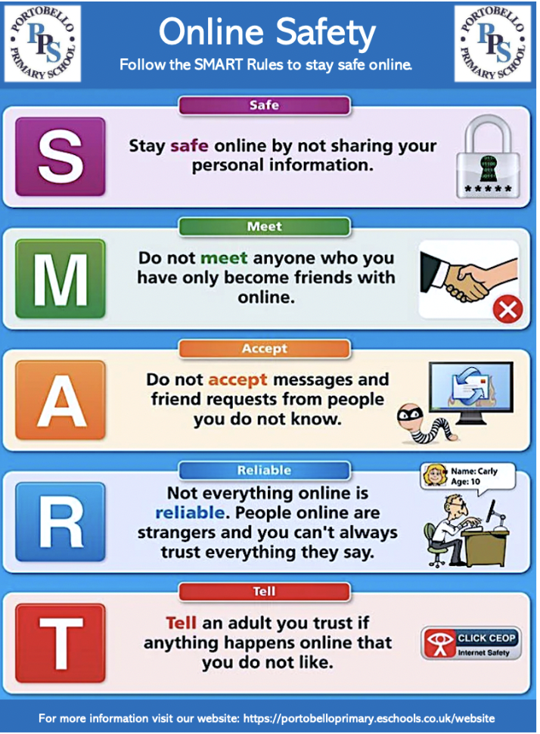
Appendix 1

