Portobello Primary School


Computing Policy (September 2022)

Ratified by Governors: January 2023

Review date: January 2024

POLICY FOR COMPUTING

Mission Statement

Creating Confidence, Empowering Excellence, Igniting Independence

Introduction

This policy sets out the rationale for the teaching and learning of Computing in school and the aims and objectives for technology use. It provides a framework within which all staff, both teaching and non-teaching, work and gives guidance on planning, teaching and assessment. Its aim is to assist planning and promote the development of Computing across the curriculum and will be subject to regular reviews in common with all other school curriculum and policy changes. It is intended to act as a reference point and to inform teachers, parents, governors, LA officers and inspectors.

This policy was reviewed in January 2023 through a process of consultation with teachers, non-teaching staff, pupils, parents and Governors.

Rationale

In Portobello Primary it is our intent to develop a love of Computing and provide children with the ability to enhance their knowledge, skills and understanding through different types of media. Our school is a place where everyone is given an education that builds on their strengths and addresses their individual needs to ensure progression. We believe that all children should be able to achieve their full potential academically, socially, emotionally and physically. In line with the 2014 National Curriculum for Computing, our aim is to provide a high-quality Computing curriculum which equips children to use technology to think creatively and to begin to comprehend the vast world in which they live, and how technology has and will change this. We acknowledge that future generations will rely heavily on their confidence with technology and digital skills in order to support their progress within their chosen career paths. Therefore, we want to enable our children to become active participants in the digital world. Key to this is that we teach them to how to be respectful, responsible and confident users of technology, aware of how keep themselves and others safe online.

More recently, technology has had an impact on the physical and emotional well-being of our children. Technology is used as a way of encouraging children to be active throughout the school day. This has had a positive impact on fitness, concentration, attention and emotional well-being. It is also a way for some children to communicate their thoughts and feelings. It is our aim to equip children with the relevant skills and knowledge that is required to understand the three core areas of Computing - Computer Science, Information Technology and Digital Literacy and to offer a broad and balanced approach to providing quality first teaching. The purpose of this policy is to outline how our Computing Curriculum intends to make this provision.

Aim

To enable all children to use technology with purpose and enjoyment:
- by providing learning opportunities which are interesting and give scope for individual responsibility and expression.
To provide children with the knowledge of different applications.
- by combining a range of software and technology including word-processing, data handling, simulations, control, data logging devices; handheld, desktop and internet technologies (including online safety across the curriculum) to solve problems and create purposeful and targeted resources.
To enable all children to develop the necessary skill to utilise technology.
- by ensuring enough access by pupils to become more proficient in the basic Computing skills and by providing opportunity outside of lessons for children to use who do not have computers at home.
To develop children’s’ understanding of how to programme digital devices and know how they work.
- by exploring and applying a variety of graphical and, where appropriate, text-based programming languages.
- by debugging a variety of intentional errors when testing and refining their resources.
- by exploring the functions of different web-based technologies such as such engines and networks.
To enable all children to meet the requirements of the Early Years Foundation Stage Curriculum and National Curriculum as fully as possible, and enabling all children to reach the highest possible standards of achievement:
- by intervening, where appropriate, to reinforce or teach a new an objective or skill.
- by selecting groups and pairs where all pupils are equally active and involved in the task, and have equal access to the computer keyboard
- by planning activities which allow different levels of achievement or incorporate possibilities for challenge work.
To enable staff to develop confidence and competence to use technology in the effective teaching of all subjects:
- by providing a central resource system of a wide variety of equipment including manuals and step by step guides for support (including utilizing digital systems, such as Outlook, Teams and Zoom, to help share and deliver this).
- by offering appropriate support and training where necessary.
To enable staff to use computing resources innovatively to support problem solving and learning across the curriculum
- by identifying opportunities to use Computing throughout the different curriculum areas.

The Teaching of Computing
In school we have developed our own curriculum utilising aspects of Project EVOLVE and National Online Safety resources. The objectives have been expanded and adapted to ensure continuity and progression in the teaching of each National Curriculum objective throughout the year groups, including Early Years.
EYFS
It is important in EYFS to give children a broad, play-based experience of Computing in a range of contexts, including outdoor play. Early years learning environments should feature technology scenarios based on experience in the real world, such as in role play. Children gain confidence, control, and language skills through opportunities to ‘paint’ on the whiteboard or drive a remote-controlled toy (graphical coding). Recording devices can support children to develop their communication skills. This is useful with children who have English as an additional language.

KEY STAGE 1
Pupils should be taught to:
- understand what algorithms are, how they are implemented as programs on digital devices, and that programs execute by following precise and unambiguous instructions
- create and debug simple programs
- use logical reasoning to predict the behaviour of simple programs
- use technology purposefully to create, organise, store, manipulate and retrieve digital content
- recognise common uses of information technology beyond school
- use technology safely and respectfully, keeping personal information private; identify where to go for help and support when they have concerns about content or contact on the internet or other online technologies

KEY STAGE 2
Pupils should be taught to:
- design, write and debug programs that accomplish specific goals, including controlling or simulating physical systems; solve problems by decomposing them into smaller parts
- use sequence, selection, and repetition in programs; work with variables and various forms of input and output
- use logical reasoning to explain how some simple algorithms work and to detect and correct errors in algorithms and programs
- understand computer networks, including the internet; how they can provide multiple services, such as the World Wide Web, and the opportunities they offer for communication and collaboration
- use search technologies effectively, appreciate how results are selected and ranked, and be discerning in evaluating digital content
- select, use and combine a variety of software (including internet services) on a range of digital devices to design and create a range of programs, systems and content that accomplish given goals, including collecting, analysing, evaluating and presenting data and information
- use technology safely, respectfully and responsibly; recognise acceptable/unacceptable behaviour; identify a range of ways to report concerns about content and contact

Curriculum Organisation
Each year group has a set of progressive objectives that cover the following areas:
- Online Safety (Covered each term)
- Key Skills and Multimedia Production
- Networks and Using The Internet
- Coding and Computational Thinking

Each term the planning will be reviewed by the Computing subject leader to inform future planning and to ensure that it is matched to the needs and competencies of the children. A more specific overview of Computing focuses is detailed within our Computing progression document. Retrieval practice and progression of skills are firmly embedded within each year groups curriculum objectives.

Differentiation and SEN
Pupils with special educational needs will be entitled to the same access to Computing as their peers. In planning lessons teachers will identify the learning goals for the majority of children as well as extension activities for the more able. Consideration will be given to modifying the task or providing peer or adult support for children with difficulty. It is important to note that pupils with learning difficulties may achieve well in computing and should be given every opportunity to provide support for others.

Assessment
Teachers regularly assess capability through observations and looking at completed work. Key objectives to be assessed are taken from the National Curriculum to assess key Computing skills each term. Assessing Computing learning is an integral part of teaching and learning and central to good practice. It should be process orientated – reviewing the way that techniques and skills are applied purposefully by pupils to demonstrate their understanding of the concepts of Computing. As assessment is part of the learning process it is essential that pupils are closely involved.
Assessment can be broken down into:
· Formative assessments are carried out during and following short focused learning opportunities. They provide pupils and teaching staff the opportunity to reflect on their learning in the context of the agreed success criteria. This feeds into planning for the next lesson or activity.
· Summative assessment should review pupils’ capability and provide a best fit level. Use of independent open-ended tasks, provide opportunities for pupils to demonstrate capability in relation to the term’s work. Gateshead LA subject trackers are completed regularly by staff. At the end of each term, teaching staff complete an online safety tracker based on children’s subject knowledge. This gives staff the opportunity to address gaps in learning.

Monitoring and Evaluation
The subject leader is responsible for monitoring the standard of the children’s work and the quality of teaching in line with the school’s monitoring cycle. This may be through lesson observations, workbook scrutiny of looking at other data for the subject. The subject leader is also responsible for supporting colleagues in the teaching of computing, for being informed about current developments in the subject, and for providing a strategic lead and direction for the subject in the school.

Role of the Computing Subject Leader
- Keep personally well-informed and up to date about the subject knowledge specific to computing.
- Prepare and keep under review a curriculum policy statement and scheme of work for the school in collaboration with the head teacher, staff, governors and any other appropriate parties.
- Provide guidance and support for staff in implementing policy and schemes of work, paying particular attention to the needs of ECT’s, teachers new to the school and supply teachers.
- Arrange appropriate school and externally based INSET for staff and evaluate its usefulness and effectiveness.
- Organise and be responsible for purchasing (subject to the allocation of funds) the resources necessary for the subject, maintaining an up to date inventory and prioritised lists of “needs”, and ensuring that all staff are aware of how to use all of the resources.
- Monitor and evaluate the effectiveness of work in the subject throughout the school, including the quality of teaching and learning and progress and achievement of pupils.
- Lead by example by fulfilling the school policy to demonstrate high standards of teaching in the subject, which sustain and raise pupil motivation, behaviour and achievement.
- Report, as required by school policy, to the head teacher, senior management team, governing body and parents on pupil progress and the achievement of strategic plans for the subject area.
- To maintain and update the digital image of the school including website content, blogs and social media.

Role of the Head Teacher
- To support the Computing subject leader in the execution of their responsibilities providing time to fulfil such responsibilities as far as is practicable, in proportion to the demands of the School Improvement Plan.
- To work in partnership with the Computing subject leader on wider school issues for the benefit of pupils, e.g. parents’ evenings, drafting bids.
- To ensure the Computing subject leader have access to appropriate continual professional development linked to their subject needs and Performance Management targets within budgetary constraints of the school.
- Use monitoring information to set targets for improvements in the subject taking account of any local and national comparative data.

Cross-curricular Opportunities
Computing contributes to many subjects within the primary curriculum and opportunities are sought to apply skills throughout a wide range of learning opportunities.

Equal Opportunities
All children are entitled to equal access to all computing equipment to develop their personal computing capability. When children work in groups care will be taken to ensure that all children are active and have equal access to the computing equipment. Children with a computer at home are encouraged to use it for educational benefit and parents will be offered advice about what is appropriate. This will be supported by content published on the school website and eschools.

Resources
The school has built up a wide range of software resources for the delivery of the Computing curriculum. iPads are available for both class use and intervention. These can be obtained from Key Stage 1 and Key Stage 2. In addition to this, there are two laptop trolleys in school which ensure classes have individual access to technology. An annual budget is available for consumable items such as print cartridges and headphones etc.

Health and Safety
Age-appropriate class and safety rules are displayed in the learning environment. Equipment is maintained to meet agreed safety standards. Children are encouraged to log computers off and prepare their learning station for use. They have chairs of the correct height, eyes level with the top of the monitor screen, and are encouraged to sit comfortably and use both hands for the keyboard.

Display of learning
Children’s work is displayed in whole school floorbooks with some individual displays within classrooms. Personal SMART safety rules are displayed within all classrooms and next to any technology (Appendix 1 and outlined in E-Safety Policy). Pupils also save work within their class folders for future reference.

Monitoring and Review

It is the responsibility of all staff to follow the principles stated in this policy. The Head Teacher, Deputy Head Teacher and Computing subject leaders will carry out monitoring of computing across school. The Curriculum Committee of The Governing Body will also be part of this process. This policy will be reviewed in January 2024.

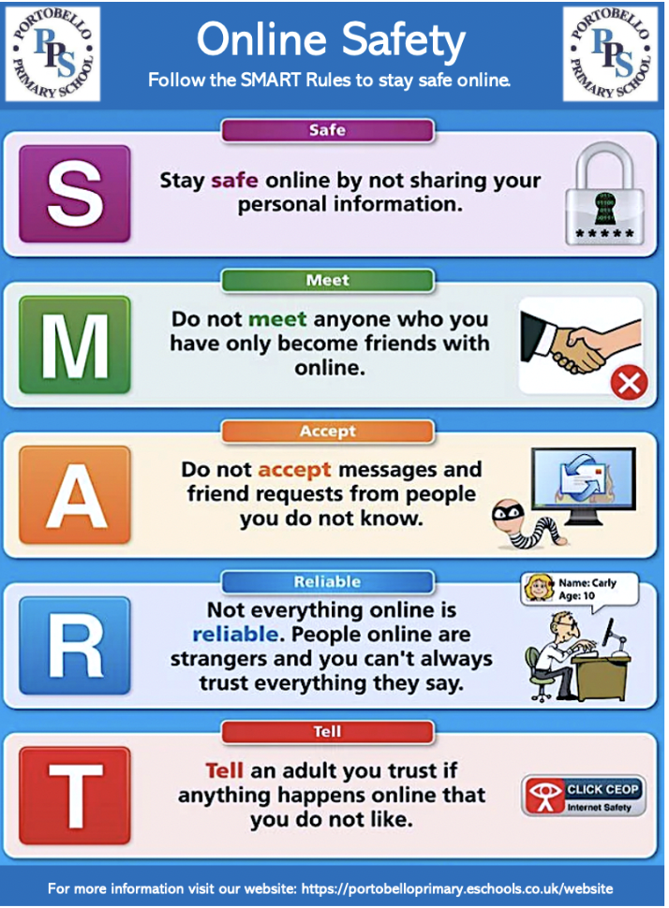
Appendix 1

